FM-BINUS-AA-FPU-745/R0

**BINUS UNIVERSITY INTERNATIONAL**

**OFF-CAMPUS EXAM**

|  |  |
| --- | --- |
| DAY – DATE: Wednesday, January 20th, 2021 at 13.00 pm – 16.00 pm, Western Indonesia Time (Jakarta,GMT+07:00) | |
| SEMESTER: | ODD Semester 2020/2021 |
| EXAM TYPE: | Off Campus Examination (FIN) |
| PROGRAM: | Computer Science |
| CODE - COURSE NAME: | COMP6341 - Multimedia and Human Computer Interaction |
| LECTURER: | D4048 - Raymond Bahana, ST., M.Sc |
| CLASS: | L1AC/L1BC |
| TIME ALLOWED: | Wednesday, January 20th, 2021 at 13.00 pm – 16.00 pm (180 minutes), Western Indonesia Time (Jakarta,GMT+07:00) |

**OFF-CAMPUS EXAM REGULATIONS:**

1. Write your answers in **correct** and **proper** **English** only.
2. Students are responsible for preparing all their needs for the exam, for example: Internet connection, laptop, etc.
3. You MUST STAND BY 5 minutes before the exam starts by signing in the system.
4. Students must submit and upload their answers through the system within the exam time.
5. A student may complete and submit the answers of the exam into the portal before – but not after – the exam time ends.
6. No additional exam time will be given for tardy students.
7. A student will be considered cheating if he or she is suspected of doing plagiarism ***as already defined in the student guidelines. Plagiarism is committed through, but not limited to, the following acts:*** 
   * ***Copying the work of another student***
   * ***Directly copying any part of another person’s work***
   * ***Summarizing the work of another person***
   * ***Using or developing an idea or thesis derived from another person’s work***
   * ***Using experimental results obtained by another person*** - ***Incitement by a student of another to plagiarize*** - ***Copy pasting from a book / textbook.***
8. Any student who is caught doing the above action (s), will be listed by name and the Ethics Committee will decide whether or not the action is considered as cheating.
9. Should the Ethics Committee consider and verify your actions as cheating, **you will immediately face expulsion** from BINUS UNIVERSITY INTERNATIONAL/~~BINUS BUSINESS SCHOOL - MASTER PROGRAM~~

*).

10.If a student finds difficulty to upload the answers, they have to contact the staff within the exam time with evidence to further process.

*) Choose one

Take Home Exam (FIN) FM-BINUS-AA-FPU-745/R0

ODD 2020/2021

# FINAL EXAM QUESTIONS

**INSTRUCTION: PLEASE READ CAREFULLY!!!**

***You can answer the questions by typing on MS Word and/or by writing on paper(s) and then take a photo(s) of the paper(s). If you have more than 1 file, please put all files in 1 folder and zip that folder. The folder name is your BinusianID. When you upload to Content.jwc.binus.ac.id, please also send it to my gmail email, with the subject in the email:* Final Exam COMP6341 – [your name] [your binusian ID]**

1. Using Lempel-Ziv algorithm, create a dictionary/table with index number and the encoding output, based on this string **(10 points)**:

**KAKIKIRIKAKIKANANKAKEKKAKEKKUKAKUKAKU**

**K|A|KI|KIR|I|KA|KIK|AN|ANK|AK|E|KK|AKE|KKU|KAK|U|KAKU|**

|  |  |  |
| --- | --- | --- |
| No | Character | Encoder Output |
| 1 | K | 0H |
| 2 | A | 0A |
| 3 | KI | 1I |
| 4 | KIR | 3R |
| 5 | I | 0I |
| 6 | KA | 1I |
| 7 | KIK | 3K |
| 8 | AN | 2N |
| 9 | ANK | 8K |
| 10 | AK | 2K |
| 11 | E | 0E |
| 12 | KK | 1K |
| 13 | AKE | 10E |
| 14 | KKU | 12U |
| 15 | KAK | 6K |
| 16 | U | 0U |
| 17 | KAKU | 15U |

1. Below is a picture of a website. Using HTML and CSS3, write the code to make this website. You may use any method you want for giving your table the right dimensions (either directly specifying the lengths in HTML or applying the lengths with inline styles). **(20 points)**

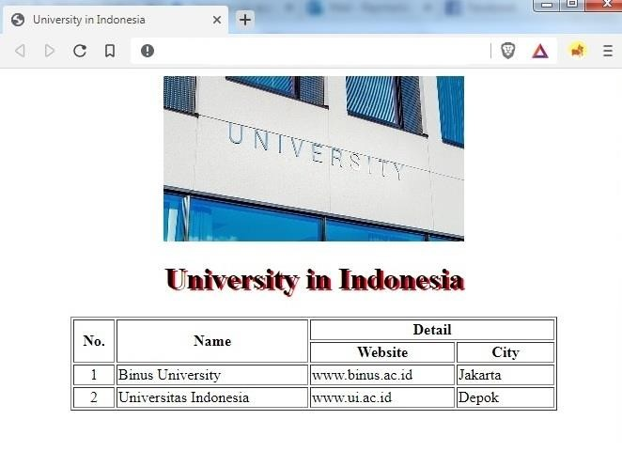

Image: logoUniv.jpg,

center

CSS3:

Font color: black,

header 1

Shadow: red

Width:

Column 1: 40 px

Column 2: 200 px

Column 3: 150 px

Column 4: 100 px

<!DOCTYPE html>

<html>

    <head>

        <title>University In Indonesia</title>

    </head>

    <style>

    h1{

        color: black;

        text-shadow: 2px 2px red;

        text-align: center;

    }

    table{

        border: 1px solid black;

        margin-left: auto;

        margin-right: auto;

    }

    th{

        border: 1px solid black;

    }

    td{

        border: 1px solid black;

    }

    </style>

<body>

    <p style="text-align: center;">

    <img src="logoUniv.jpg">

    </p>

    <h1>My First Heading</h1>

    <table>

        <tr>

            <th rowspan="2" style="width:40px">No</th>

            <th rowspan="2" style="width:200px">Name</th>

            <th colspan="2" style="width:250px">Detail</th>

        </tr>

        <tr>

            <td style="width:150px">Website</td>

            <td style="width:100px">City</td>

        </tr>

        <tr>

            <td>1</td>

            <td>Binus University</td>

            <td>www.binus.ac.id</td>

            <td>Jakarta</td>

        </tr>

        <tr>

            <td>2</td>

            <td>Universitas Indonesia</td>

            <td>www.ui.ac.id</td>

            <td>Depok</td>

        </tr>

    </table>

</body>

</html>

1. Please count the frequency of occurrence every character, the character code (in binary and use tree), and calculate the percentage of compression to compress the sentence below **(20 points)**:

**A SKUNK SAT ON A STUMP AND THUNK THE STUMP STUNK, BUT THE STUMP THUNK THE SKUNK STUNK**

using:

* 1. Shannon-Fano Algorithm
  2. Huffman Coding

1. 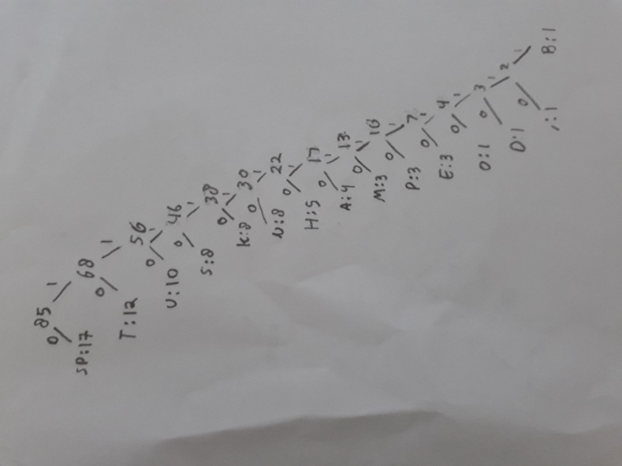

|  |  |  |  |  |
| --- | --- | --- | --- | --- |
| No | Character | Occurrence | Character code | Bit used |
| 1 | sp | 17 | 0 | 17 |
| 2 | T | 12 | 01 | 24 |
| 3 | U | 10 | 110 | 30 |
| 4 | S | 8 | 1110 | 32 |
| 5 | K | 8 | 11110 | 40 |
| 6 | N | 8 | 111110 | 48 |
| 7 | H | 5 | 1111110 | 35 |
| 8 | A | 4 | 11111110 | 32 |
| 9 | M | 3 | 111111110 | 27 |
| 10 | P | 3 | 1111111110 | 30 |
| 11 | E | 3 | 11111111110 | 33 |
| 12 | O | 1 | 111111111110 | 12 |
| 13 | D | 1 | 1111111111110 | 13 |
| 14 | , | 1 | 11111111111110 | 14 |
| 15 | B | 1 | 11111111111111 | 14 |
| Total Bit used | | | | 401 |

**(680 – 401 / 680)*100% = 41.02% compression**

**b.**

|  |  |  |  |  |
| --- | --- | --- | --- | --- |
| No | Character | Occurrence | Character code | Bit used |
| 1 | sp | 17 | 111 | 51 |
| 2 | T | 12 | 110 | 36 |
| 3 | U | 10 | 1011 | 40 |
| 4 | S | 8 | 1010 | 32 |
| 5 | K | 8 | 1001 | 32 |
| 6 | N | 8 | 1000 | 32 |
| 7 | H | 5 | 011 | 15 |
| 8 | A | 4 | 0101 | 16 |
| 9 | M | 3 | 0100 | 12 |
| 10 | P | 3 | 0011 | 12 |
| 11 | E | 3 | 0010 | 12 |
| 12 | O | 1 | 00011 | 5 |
| 13 | D | 1 | 00010 | 5 |
| 14 | , | 1 | 00001 | 5 |
| 15 | B | 1 | 00000 | 5 |
| Total Bit used | | | | 301 |

**(680 – 301 / 680)*100% = 55.73% compression**

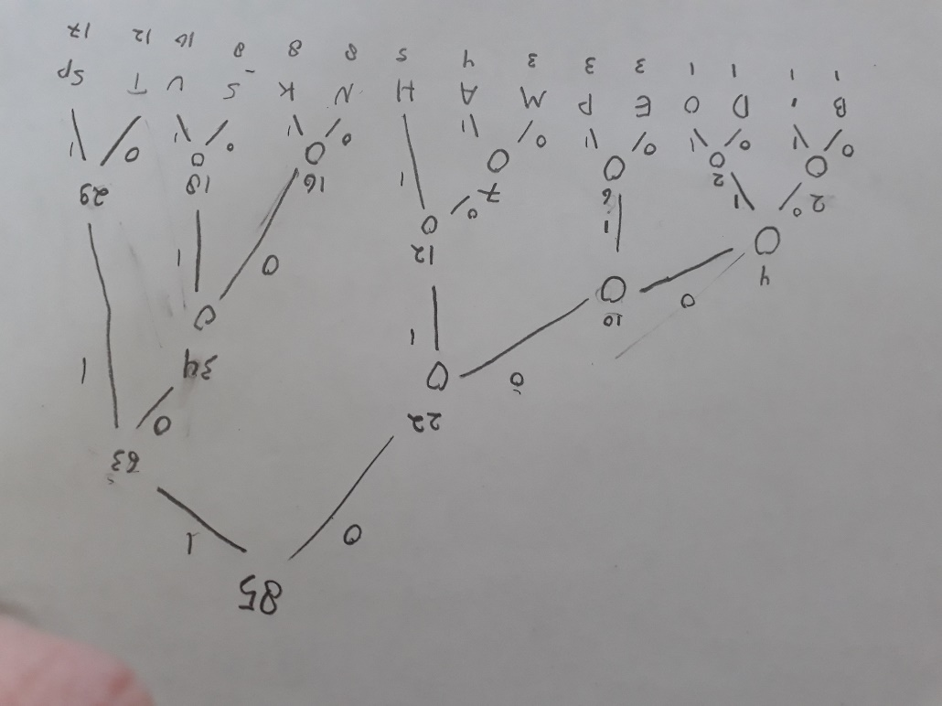

1. Scenario is a story about a user using the system. Based on your persona assignment (if you missed this assignment, write about your persona first before creating a scenario), create a scenario that describes how your persona is playing your game application. The scenario should be different with the scenario that you posted in the forum (**10 points)**

Ivan was given a game from his parent, it is a color-based game. The game use color as weapon in rock-paper-scissor manner. Ivan was perplexed at first since he is often confused between colors name and often lose the game. The color that he thought red, cannot beat yellow. After experimenting, turns out the color red wasn’t the one that he thought it was, the color he thought was red turns out to be blue. Ivan then corrects his mistake and use the actual red. Ivan then finally able to correct his mistake and able to name color correctly.

Page **1** of **2** COMP6341 - Multimedia and Human Computer Interaction BINUS INTERNATIONAL

Take Home Exam (FIN) FM-BINUS-AA-FPU-745/R0

## ODD 2020/2021

1. Pick one of screenshots from your game.

Copy that screenshot on your answer sheet.

Then, describe at least four of the Nielsen’s ten heuristics that you followed. List each separately. Do you find any violation in your screenshot? If yes, please explain. **(10 points)**

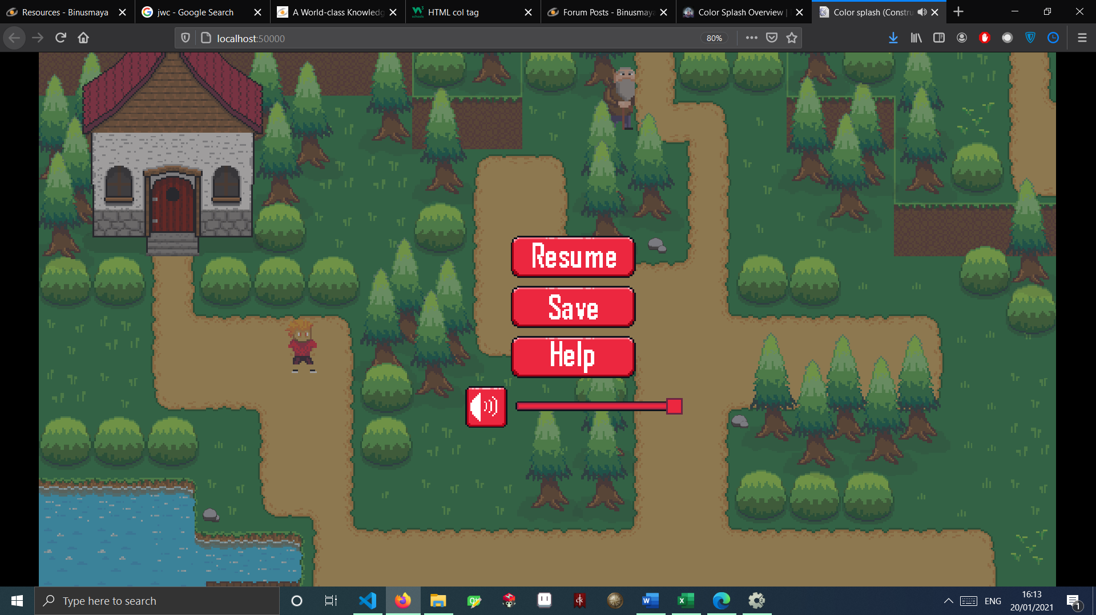

**Recognition than recall**, My game have a sound icon that can be recognized as volume setting since it is often used in many application.

**Consistency and standards**, My game have terms that follow the common word used in many games like “Resume”, “Save”, and “Help”.

**Match between system and the real world**, My game provide a dark overlay to the screen when paused to tell the user that the game is paused.

**Aesthetic and minimalist design**, My game did not have a long text that covered the whole screen, every information is delivered in short simple word or image.

1. What is the difference between useful and usable? Based on your screenshot at number 4, which part on your game is usable (if any) and which part is useful? **(10 points)**

Useful is a tool that will be used by the user to provide the user need or give information to the user in large frequency. Usable is regarded as something that optional to the user.

The example of useful tool in the screenshot is the resume button, it is required for the user to continue the game and thus regarded as useful.

The example of usable tool in the screenshot is the save button, user might not want to save the game when quitting the game or can possibly finish the game without saving thus making the save button as usable.

1. When you developed your game application, which development process that you used, or the traditional software development process (Waterfall model)? And explain what you did in every step **(20 points)**

The game was developed with a waterfall concept.

**Requirement analysis**, the first step is to come up with a game idea that fits the theme .

**System design**, the game resource such as asset and sounds were prepared or made. After

**Implementation**, after all resource is prepared, the game is made through applying logic code.

**Testing**, after the game is done, I look for bugs and error that can potentially be made by the user.

**Maintenance**, after testing, I fix all the bug before repeating the whole process for more feature to the game.

## Page **2** of **2** COMP6341 - Multimedia and Human Computer Interaction BINUS INTERNATIONAL